R DATA VISUALIZATION PROJECT
Exploring New York Air Quality Measurements (1973)
Prepared by: Prachi Gupta
Technology: R • ggplot2 • dplyr
Project duration: approximately 32 hours

Dataset | datasets::airquality
Observations | 153 daily measurements
Period | May–September 1973
Main variables | Ozone, Solar Radiation, Wind, Temperature, Month, Day

1. Executive Summary
This report demonstrates how R visualization can convert a small environmental dataset into a clear analytical story. The analysis uses the built-in datasets::airquality data, containing 153 daily measurements from New York between May and September 1973. Six visualizations were developed to examine ozone distribution, seasonal temperature, ozone trends, the relationship between temperature and ozone, wind-speed variation, and correlations among key variables.
The analysis shows a strong seasonal pattern: average ozone is highest in August and lowest in May, while August is the warmest month on average. Temperature and ozone have a positive correlation of approximately 0.70, whereas wind and ozone have a negative correlation of approximately -0.60. These relationships are descriptive rather than causal; the dataset is historical and does not by itself establish why the measurements changed.

2. Dataset Overview
The airquality dataset is a public R dataset describing daily air-quality and weather measurements in New York from May 1 through September 30, 1973. It contains 153 observations and six variables. Ozone is measured in parts per billion, Solar.R is solar radiation, Wind is average wind speed in miles per hour, Temp is maximum daily temperature in degrees Fahrenheit, and Month/Day identify the observation date.
Variable | Meaning | Role in analysis
Ozone | Ozone concentration (ppb) | Primary air-quality measure
Solar.R | Solar radiation | Environmental explanatory variable
Wind | Average wind speed (mph) | Weather/explanatory variable
Temp | Maximum daily temperature (°F) | Weather/explanatory variable
Month | Month number (5–9) | Seasonal grouping
Day | Day of month | Daily ordering

3. Data Quality and Preparation
The dataset contains missing values in Ozone and Solar.R. Missing observations were not silently replaced for the visualizations that require those measurements. Instead, ggplot2's missing-value handling is allowed to exclude incomplete points from the relevant calculation. Temperature and Wind contain complete observations. This approach preserves the original measurements and avoids introducing artificial values.
Rows: 153 | Missing Ozone: 37 | Missing Solar.R: 7 | Missing Wind: 0 | Missing Temp: 0

4. Visualizations and Findings

4.1 Histogram — Ozone Distribution
Purpose: understand the overall distribution and identify concentration and extreme values.
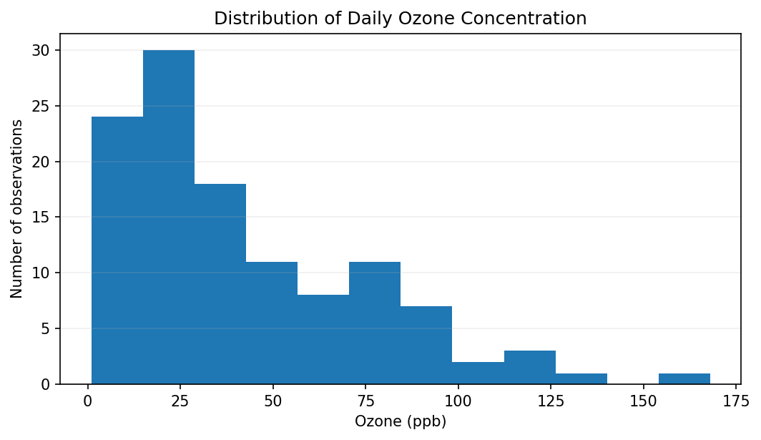
Figure: 4.1 Histogram — Ozone Distribution
R code used to generate the visualization:
library(ggplot2)
data(airquality)
ggplot(airquality, aes(x = Ozone)) +
geom_histogram(bins = 12, fill = "#2F75B5",
color = "white", na.rm = TRUE) +
labs(title = "Distribution of Daily Ozone Concentration",
x = "Ozone (ppb)", y = "Number of observations") +
theme_minimal()

Interpretation:
The histogram shows that most observed ozone values are concentrated toward the lower end of the distribution, with a smaller number of high-ozone days creating a right-skewed shape. The mean ozone concentration is about 42.1 ppb and the median is 31.5 ppb. The maximum observed value is 168 ppb. This visualization was selected because a histogram is effective for understanding the shape, spread, and unusually high observations of a continuous variable.

4.2 Bar Chart — Monthly Temperature
Purpose: compare average temperature across the five months.
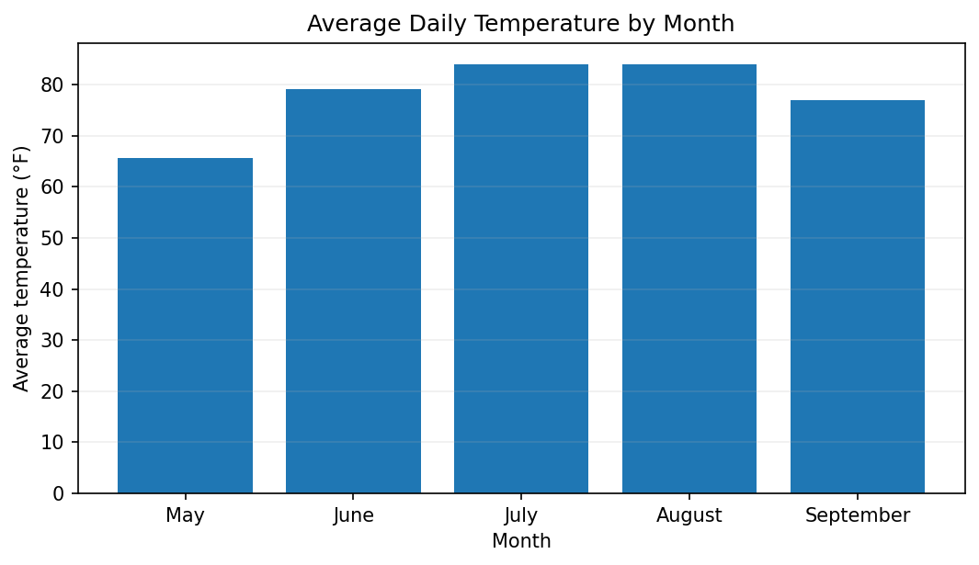
Figure: 4.2 Bar Chart — Monthly Temperature
R code used to generate the visualization:
library(dplyr)
library(ggplot2)
monthly_temp <- airquality %>%
group_by(Month) %>%
summarise(mean_temp = mean(Temp))
ggplot(monthly_temp, aes(x = factor(Month), y = mean_temp)) +
geom_col(fill = "#ED7D31") +
labs(title = "Average Daily Temperature by Month",
x = "Month", y = "Average temperature (°F)") +
theme_minimal()

Interpretation:
The bar chart makes the seasonal temperature pattern easy to compare. Average temperature rises from May into summer, peaks in August, and then declines toward September. The overall average maximum daily temperature is about 77.9°F. A bar chart was selected because the objective is a direct comparison between discrete month groups.

4.3 Line Chart — Seasonal Ozone Trend
Purpose: communicate how average ozone changes as the season progresses.
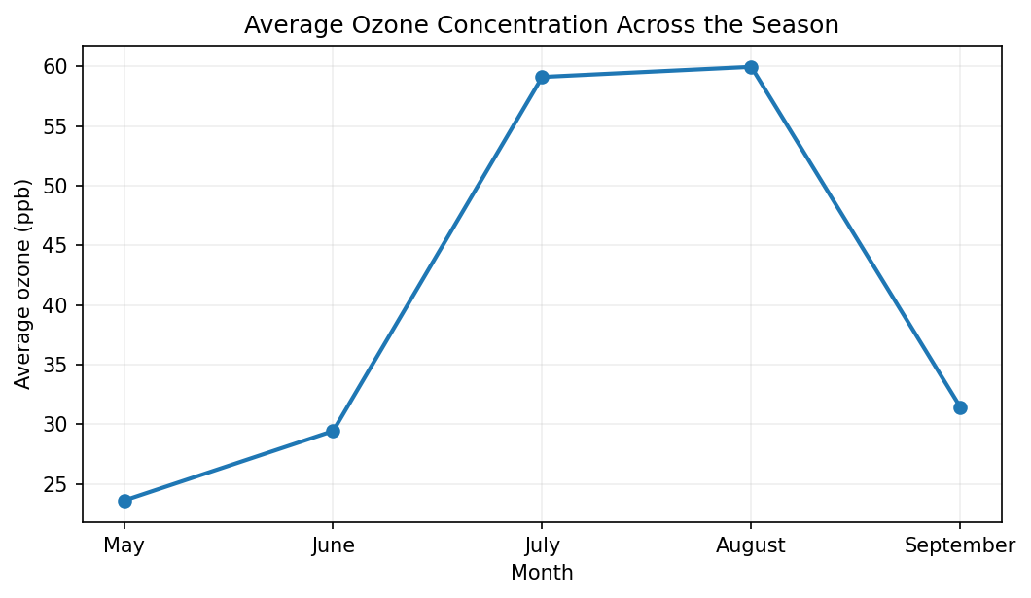
Figure: 4.3 Line Chart — Seasonal Ozone Trend
R code used to generate the visualization:
library(dplyr)
library(ggplot2)
monthly_ozone <- airquality %>%
group_by(Month) %>%
summarise(mean_ozone = mean(Ozone, na.rm = TRUE))
ggplot(monthly_ozone, aes(x = Month, y = mean_ozone)) +
geom_line(linewidth = 1.1, color = "#4472C4") +
geom_point(size = 2.5, color = "#4472C4") +
scale_x_continuous(breaks = 5:9) +
labs(title = "Average Ozone Concentration Across the Season",
x = "Month", y = "Average ozone (ppb)") +
theme_minimal()

Interpretation:
The line chart highlights the seasonal movement in ozone. Average ozone increases strongly into July and remains relatively high in August before declining in September. August has the highest monthly average, while May has the lowest. A line chart is appropriate because the months form an ordered sequence and the main question concerns change across time.

4.4 Scatter Plot — Temperature vs Ozone
Purpose: examine whether warmer days tend to coincide with higher ozone readings.
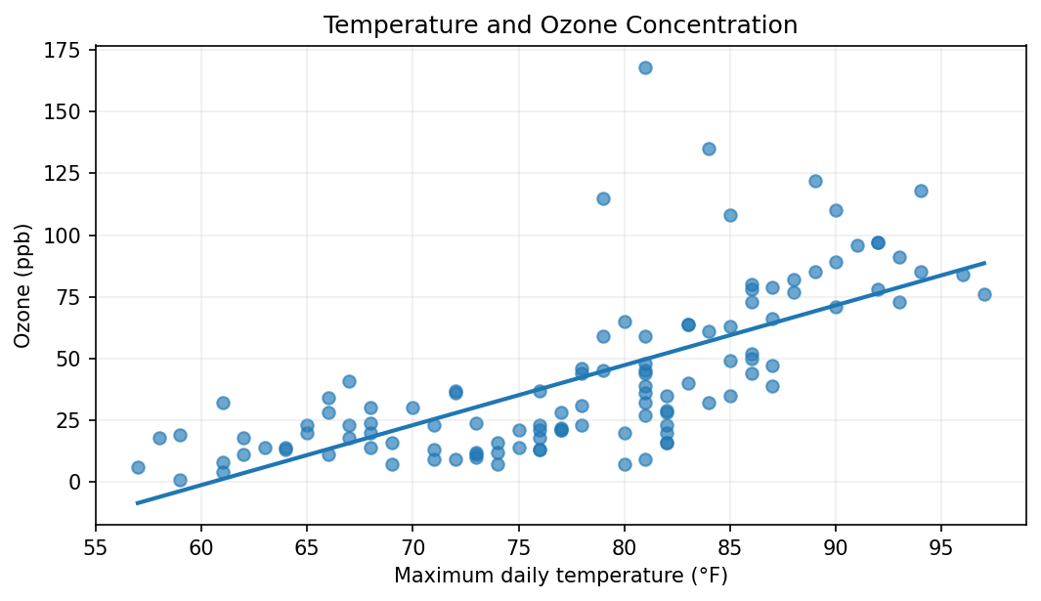
Figure: 4.4 Scatter Plot — Temperature vs Ozone
R code used to generate the visualization:
library(ggplot2)
ggplot(airquality, aes(x = Temp, y = Ozone)) +
geom_point(alpha = 0.65, na.rm = TRUE) +
geom_smooth(method = "lm", se = FALSE, na.rm = TRUE) +
labs(title = "Temperature and Ozone Concentration",
x = "Maximum daily temperature (°F)",
y = "Ozone (ppb)") +
theme_minimal()

Interpretation:
The scatter plot shows a positive association between temperature and ozone: warmer days generally tend to have higher ozone measurements, although the points are widely spread. The Pearson correlation is approximately 0.70. The fitted trend line summarizes the direction of the relationship but should not be interpreted as proof that temperature alone causes ozone changes. A scatter plot was selected because it shows both the relationship and the variability of individual daily observations.

4.5 Boxplot — Wind-Speed Variation
Purpose: compare monthly variability rather than only monthly averages.
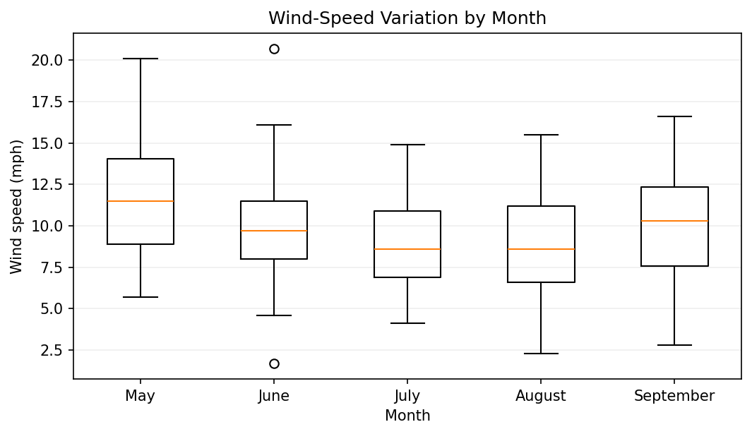
Figure: 4.5 Boxplot — Wind-Speed Variation
R code used to generate the visualization:
library(ggplot2)
ggplot(airquality, aes(x = factor(Month), y = Wind)) +
geom_boxplot(fill = "#70AD47", na.rm = TRUE) +
labs(title = "Wind-Speed Variation by Month",
x = "Month", y = "Wind speed (mph)") +
theme_minimal()

Interpretation:
The boxplot compares the central tendency and spread of wind speed across months. It shows that wind conditions vary within every month, with some months having wider ranges than others. The overall mean wind speed is about 9.96 mph. A boxplot was chosen because it communicates median, spread, and potential unusually high or low observations more effectively than a simple average.

4.6 Correlation Heatmap — Key Variables
Purpose: provide a compact overview of relationships among ozone, solar radiation, wind and temperature.
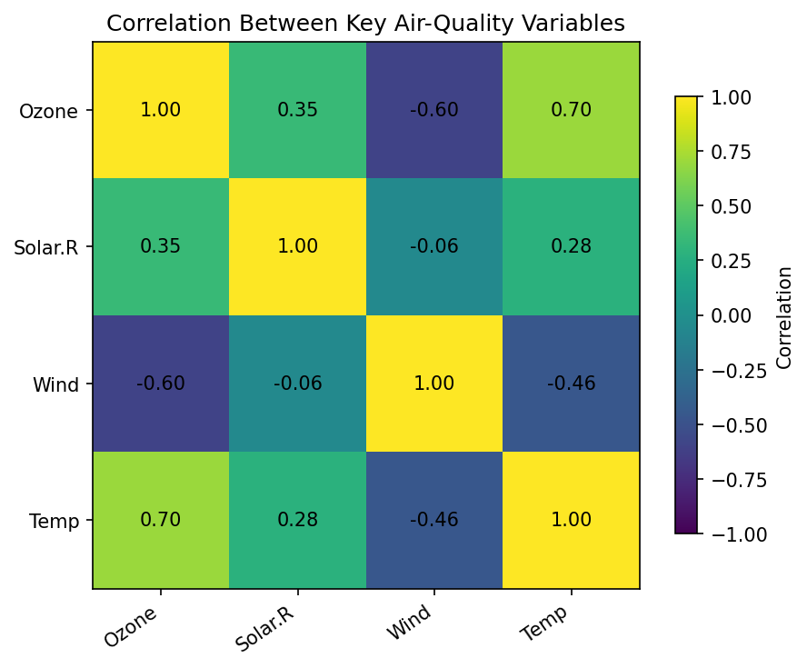
Figure: 4.6 Correlation Heatmap — Key Variables
R code used to generate the visualization:
library(ggplot2)
library(tidyr)
cor_data <- cor(airquality[, c("Ozone", "Solar.R", "Wind", "Temp")],
use = "complete.obs")
# Optional heatmap using the correlation matrix
cor_df <- as.data.frame(as.table(cor_data))
ggplot(cor_df, aes(Var1, Var2, fill = Freq)) +
geom_tile() +
geom_text(aes(label = round(Freq, 2))) +
scale_fill_gradient2(limits = c(-1, 1)) +
labs(title = "Correlation Between Key Variables",
x = NULL, y = NULL, fill = "Correlation") +
theme_minimal()

Interpretation:
The correlation view summarizes pairwise linear relationships. The strongest relationship relevant to the main story is between temperature and ozone (approximately 0.70), while wind and ozone show a negative relationship (approximately -0.60). Correlation is useful for screening relationships, but it does not prove causation and can be affected by omitted variables and the historical nature of the sample.

5. Key Insights for a Non-Technical Audience
- Ozone levels were not evenly distributed. Most days had relatively moderate ozone values, while a smaller group of days recorded much higher values.
- Temperature followed a clear seasonal pattern, becoming warmer through summer and reaching its highest monthly average in August.
- Ozone also showed a seasonal pattern, reaching its highest monthly average in August and its lowest in May.
- Temperature and ozone moved together to a noticeable degree (correlation ≈ 0.70), suggesting that hotter days in this historical sample were often associated with higher ozone.
- Wind and ozone moved in opposite directions to some extent (correlation ≈ -0.60), although this relationship is not sufficient to establish a causal mechanism.
- The boxplot demonstrates why averages alone can be misleading: daily weather conditions varied substantially within the same month.

6. Why These Visualization Types Were Chosen
Chart | Question answered | Why appropriate
Histogram | What does ozone distribution look like? | Shows shape, concentration and extreme values.
Bar chart | Which month is warmer on average? | Makes category-to-category comparisons immediate.
Line chart | How does ozone change through the season? | Emphasizes ordered change over time.
Scatter plot | How are temperature and ozone related? | Shows individual observations and relationship strength.
Boxplot | How variable is wind within each month? | Shows median, spread and unusual observations.
Heatmap | Which variables move together? | Summarizes several correlations compactly.

7. Limitations
- The dataset covers only May–September 1973, so the findings should not be treated as a description of current New York air quality.
- There are missing observations for Ozone and Solar.R; plots involving these variables use only available observations.
- The analysis is descriptive. Correlation does not demonstrate causation.
- The data covers a single location and historical period, limiting generalization to other cities or years.

8. 32-Hour Work Plan / Effort Log
Activity | Time
Dataset understanding and variable definitions | 4 hours
Data quality review and missing-value assessment | 4 hours
R/ggplot2 visualization design | 8 hours
Chart interpretation and narrative writing | 7 hours
Code review, formatting and documentation | 5 hours
Final quality check and submission preparation | 4 hours
Total planned effort: approximately 32 hours, within the requested 30–35 hour scope.

9. Reproducibility — Complete R Script
# R Data Visualization Project
# Dataset: datasets::airquality
library(ggplot2)
library(dplyr)
library(tidyr)
data(airquality)
# Overview
dim(airquality)
str(airquality)
summary(airquality)
colSums(is.na(airquality))
# 1. Histogram
ggplot(airquality, aes(x = Ozone)) +
geom_histogram(bins = 12, fill = "#2F75B5", color = "white", na.rm = TRUE) +
labs(title = "Distribution of Daily Ozone Concentration",
x = "Ozone (ppb)", y = "Number of observations") +
theme_minimal()
# 2. Monthly temperature bar chart
monthly_temp <- airquality %>%
group_by(Month) %>%
summarise(mean_temp = mean(Temp))
ggplot(monthly_temp, aes(x = factor(Month), y = mean_temp)) +
geom_col(fill = "#ED7D31") +
labs(title = "Average Daily Temperature by Month",
x = "Month", y = "Average temperature (°F)") +
theme_minimal()
# 3. Monthly ozone line chart
monthly_ozone <- airquality %>%
group_by(Month) %>%
summarise(mean_ozone = mean(Ozone, na.rm = TRUE))
ggplot(monthly_ozone, aes(x = Month, y = mean_ozone)) +
geom_line(linewidth = 1.1, color = "#4472C4") +
geom_point(size = 2.5, color = "#4472C4") +
scale_x_continuous(breaks = 5:9) +
labs(title = "Average Ozone Concentration Across the Season",
x = "Month", y = "Average ozone (ppb)") +
theme_minimal()
# 4. Scatter plot
ggplot(airquality, aes(x = Temp, y = Ozone)) +
geom_point(alpha = 0.65, na.rm = TRUE) +
geom_smooth(method = "lm", se = FALSE, na.rm = TRUE) +
labs(title = "Temperature and Ozone Concentration",
x = "Maximum daily temperature (°F)", y = "Ozone (ppb)") +
theme_minimal()
# 5. Wind boxplot
ggplot(airquality, aes(x = factor(Month), y = Wind)) +
geom_boxplot(fill = "#70AD47", na.rm = TRUE) +
labs(title = "Wind-Speed Variation by Month",
x = "Month", y = "Wind speed (mph)") +
theme_minimal()
# 6. Correlation heatmap
cor_data <- cor(airquality[, c("Ozone", "Solar.R", "Wind", "Temp")],
use = "complete.obs")
cor_df <- as.data.frame(as.table(cor_data))
ggplot(cor_df, aes(Var1, Var2, fill = Freq)) +
geom_tile() +
geom_text(aes(label = round(Freq, 2))) +
scale_fill_gradient2(limits = c(-1, 1)) +
labs(title = "Correlation Between Key Variables",
x = NULL, y = NULL, fill = "Correlation") +
theme_minimal()
# Key descriptive statistics
mean(airquality$Ozone, na.rm = TRUE)
median(airquality$Ozone, na.rm = TRUE)
max(airquality$Ozone, na.rm = TRUE)
cor(airquality$Temp, airquality$Ozone, use = "complete.obs")
cor(airquality$Wind, airquality$Ozone, use = "complete.obs")

10. Conclusion
The project demonstrates that effective visualization is not simply about producing attractive charts; it is about selecting a chart that answers a specific analytical question. Using R and ggplot2, the analysis moved from distribution to comparison, trend, relationship, variability and correlation. The combined evidence indicates clear seasonal variation in the 1973 measurements and a noticeable positive association between temperature and ozone. The final report is designed so that a non-technical reader can understand both what each chart shows and why it matters.

References
R datasets package — airquality: New York Air Quality Measurements. Public documentation describes 153 daily observations from May–September 1973 and the six variables used in this report.
Public dataset mirror used for verification: DataScienceDojo / public datasets repositories and the R datasets documentation.

